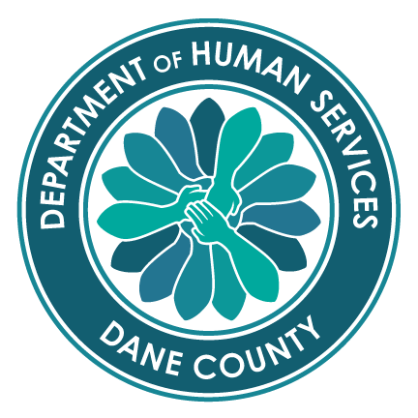
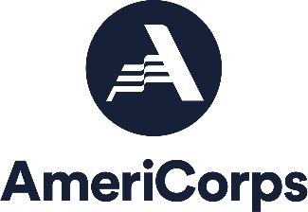
Partners for After School Success (PASS)

A Community-Based AmeriCorps Program

Dane County Department of Human Services
Division of Children, Youth & Families

PASS AMERICORPS MEMBER 1700 Hour POSITION DESCRIPTION
Position Summary:
PASS AmeriCorps members are responsible for serving youth at agencies or school sites throughout Dane County. PASS activities include academic coaching and tutoring; engaging youth in community service; and providing extended learning programs including employment skill training. In addition to agency responsibilities, PASS AmeriCorps members engage in professional development activities and participate in national and/or local community service projects and AmeriCorps events.

AmeriCorps Requirements: AmeriCorps members must meet the following requirements outlined by the State and Federal AmeriCorps rules, including:
1) Serve 1700 hours by August 24
2) Be a citizen of the United States, a United States national, or a legal permanent resident of the United States
- Have a high school degree or equivalent (or agrees to obtain a high school diploma or GED)
- Be a least 17 years old
- Pass a criminal background check including National Sex Offender Registry, State(s) registry and FBI
- Have not served more than four fulltime AmeriCorps terms of service or received two fulltime education awards
- Follow all PASS policies and AmeriCorps rules and regulations as outlined in the Member Agreement

PASS Requirements--Youth Work: PASS AmeriCorps members spend at least 80% of their time providing services to youth at a host site located in Dane County. PASS service activities include academic coaching, developing and facilitating extended learning programs during or after school, and engaging youth and adult volunteers in community service.
Requirements include:
- Complete a Work Plan that outlines professional goals and a schedule to provide PASS program activities
- Provide academic coaching, develop and facilitate extended learning programs, engage youth in community service
- Understand and actively contribute to PASS meeting its program performance measures
- Complete regular reporting in MOST MIS system related to PASS service activities and performance measures
- Serve as a positive adult role model for youth
- Maintain appropriate boundaries and conduct with youth (a vulnerable population) at all times
- Respect youth cultural differences

PASS Requirements—Host Site team member
- Be punctual and follow assigned work schedule
- Learn and follow host site policies and procedures
- Provide own transportation to host site (some sites on bus routes)
- Set regular consultation and reflection times with supervisor (weekly meetings)
- Keep direct supervisor informed about concerns, conflicts or problems
- Complete tasks as assigned in an accurate and timely manner include entry of service hours
- Be a cooperative team member
- Enter service hours in On Corps in an accurate and timely manner

PASS Requirements—Professional Development/Community Service: PASS AmeriCorps members spend approximately 20% of their time collaborating with other AmeriCorps members on community service or professional development activities. Requirements to this end include:
- Participate in Serve Wisconsin AmeriCorps events
- Participate in citizenship training provided by PASS and group service events
- Participate in professional development meetings
- Participate in at least one national day of service (i.e. September 11, MLK Day, Global Youth Service Day)
- Participate in local or regional natural disasters as needed and Alternative Spring Break service week (optional)

