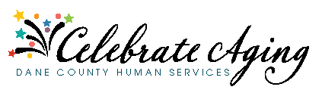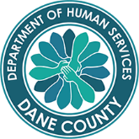
Celebrate Aging! with Dane County Department of Human Services

